Jebel Ali Residence
FACT SHEET

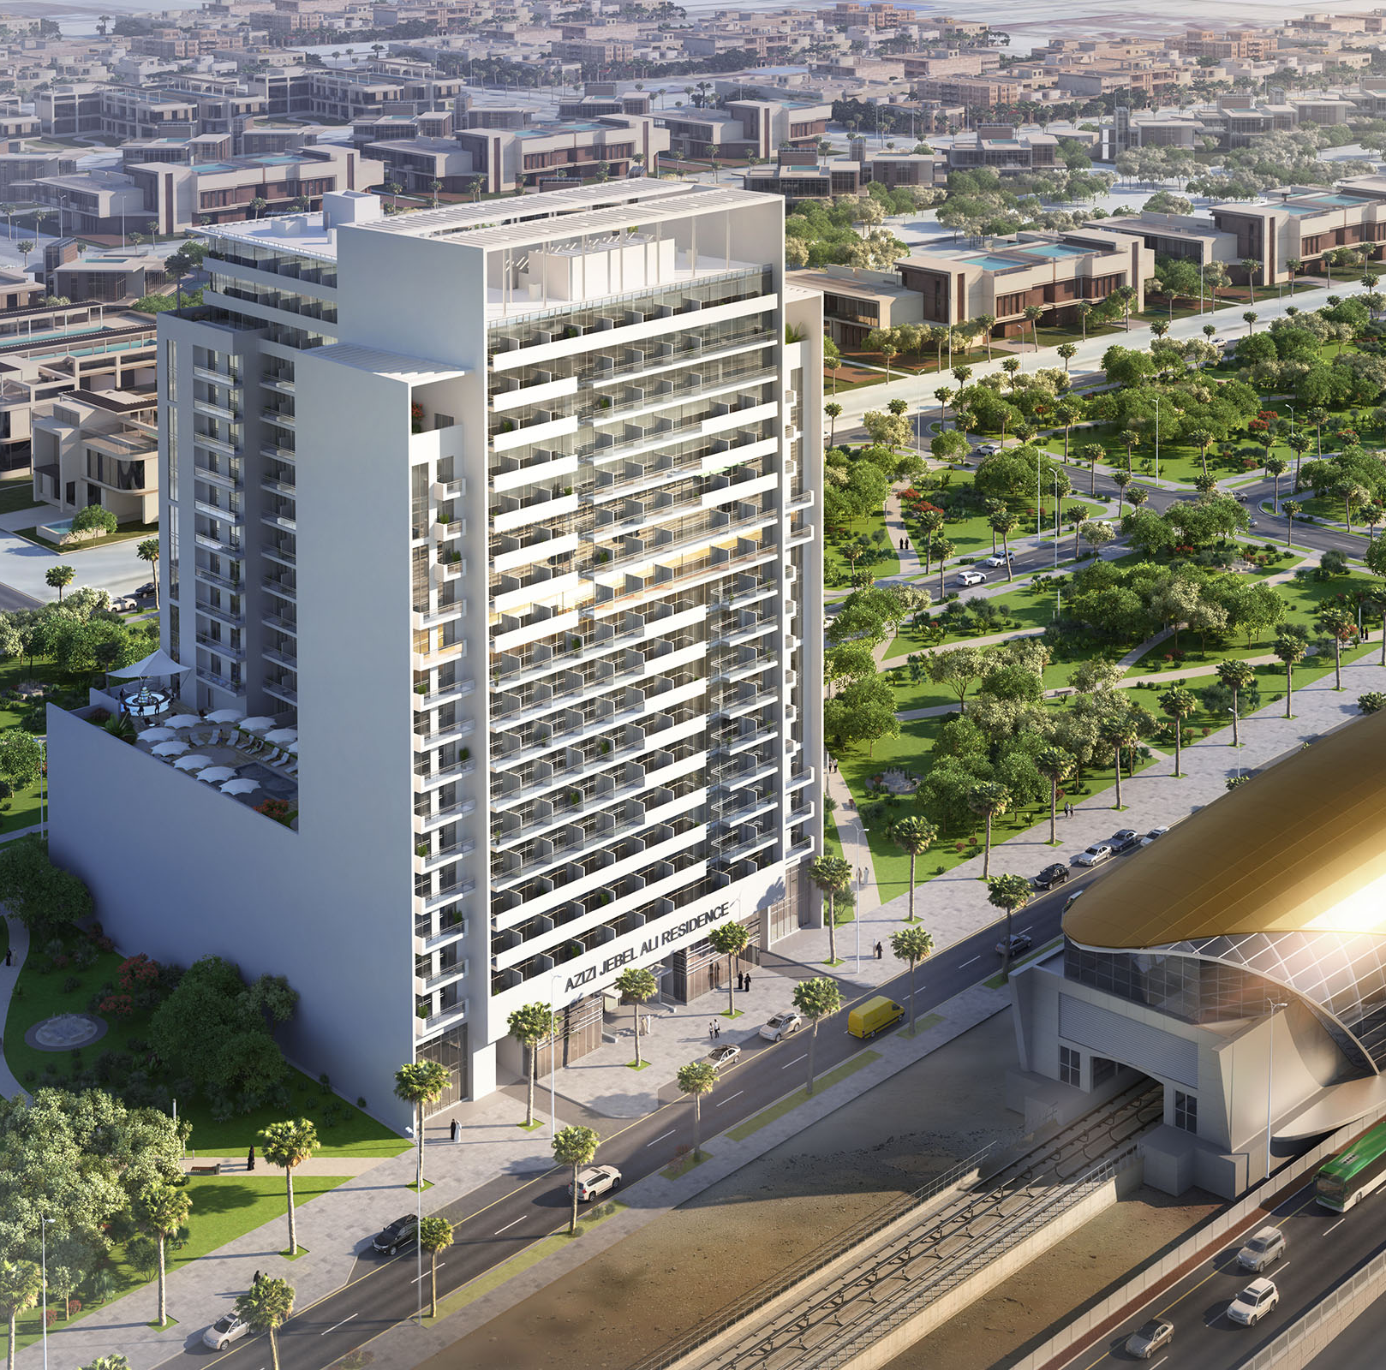

GROUND FLOOR PLAN

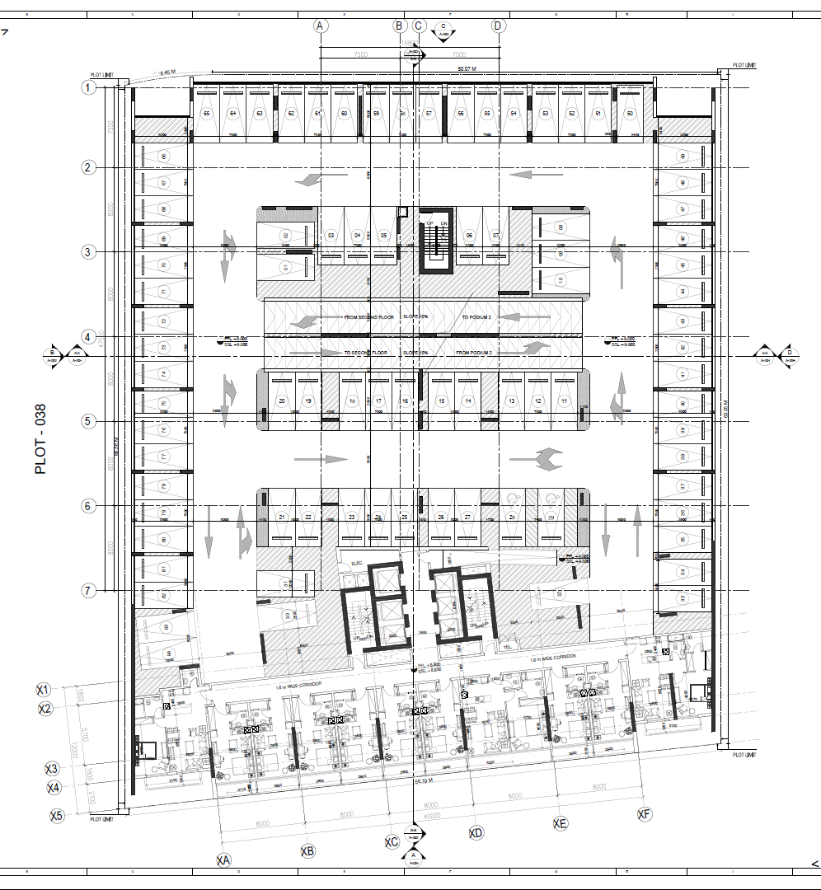

TYPICAL FLOOR PLAN FROM 1ST TO 3RD

4TH FLOOR PLAN

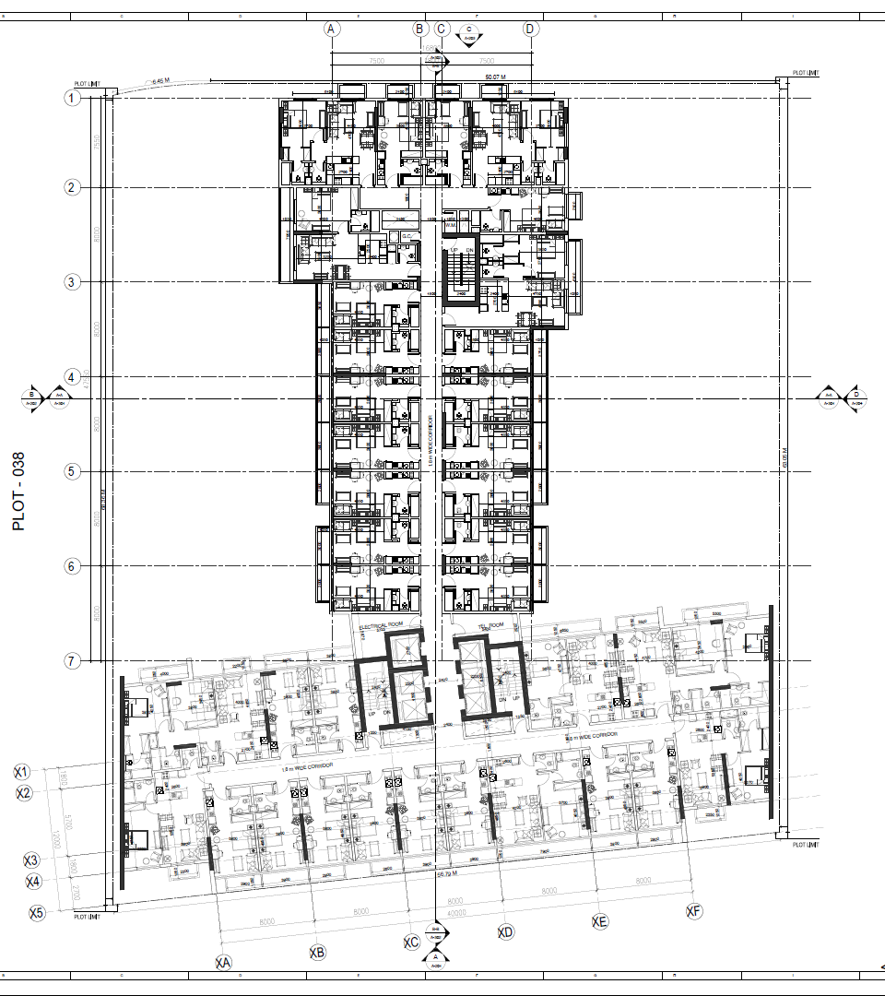

TYPICAL FLOOR PLAN FROM 5TH TO 13TH

14TH FLOOR PLAN

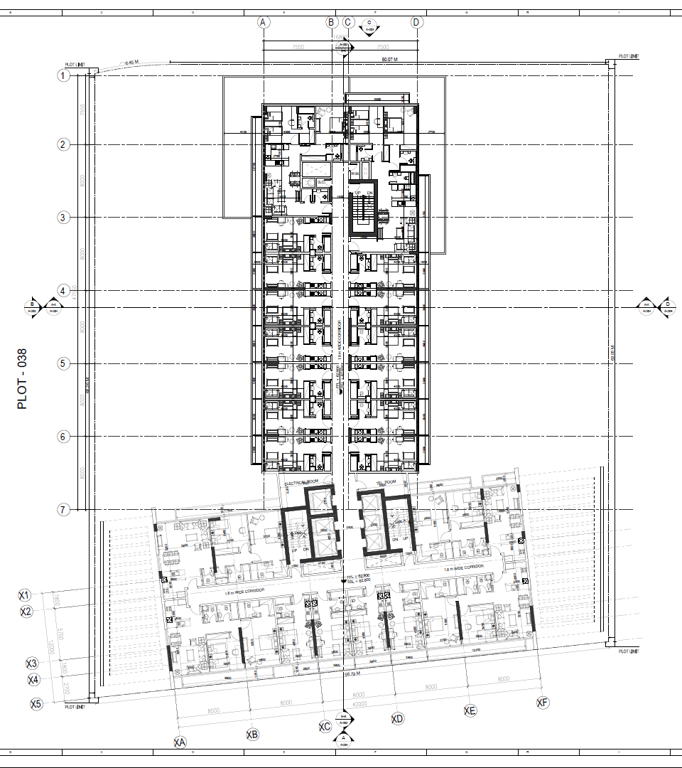

15- 17TH FLOOR PLAN

Project Summary
AZIZI DEVELOPMENTS is proud to introduce Jebel Ali Residence, a high-end residential apartment building with facilities in Downtown Jebel Ali district of Dubai.
The building features a unique design that creates a unique look that is unsurpassed in Dubai.

Jebel Ali Residence features 479 luxurious apartments that offer an unparalleled level of convenience and amenities. Each apartment is furnished and delivered with a modern and fresh interior design.

Location
Located in Downtown Jebel Ali District
Adjacent to UAE exchange metro station
Fantastic views Sheikh Zayed Road
Nearby Dubai expo 2020
Direct access to the Sheikh Zayed Road
10 minutes’ drive from Almaktoum airport, Dubai south, and Ibn Batutta Mall
5 minutes’ drive from the upcoming Dubai expo 2020

Project Details
Plot Area: 40,138 sq. ft.
Total Construction Area: 536,823 sq. ft.
Total Height: 77.35 M
Levels: B + G + 2P + 17

Type
Residential Building with Facilities

Unit Mix
Studio Apartment: 349 No. “Average Area 370 sq. ft. “ 73%
1 Bedroom Apartment: 87 No. “Average Area 720 sq. ft. “ 18%
2 Bedrooms Apartment: 43 No. “Average Area 1200 sq. ft. “ 9%
Total number of apartments: 479

Amenities & Services
Landscaped gardens, gymnasium, swimming pool, retail areas, covered parking.

Furniture
Full furniture package included

Unit Features:
- Kitchen cabinets and countertops with refrigerator, washing machine & cooker.
- Balconies as per unit plan.
- Wardrobes in bedrooms.
- Fully tiled bathrooms, en-suites and guest toilets, wherever applicable
- Shower or bath tub with handle and shower in each bathroom.
- Vanity Units and mirrors
- Centrally air conditioned
- Double glazed windows
- DU television and telephone connections
- Satellite master antenna “SMATV connection “
- Provision for High speed internet access “Fiber optic connection “
- Ceramic floor tiling

